Cron job
The WebParsingUtils class provides utilities for downloading, extracting, processing, and persisting geospatial and address data from a web source. It integrates with UkrPoshta API to fetch data about addresses in Ukraine, and the OpenStreetMap (OSM) Nominatim API to fetch coordinates for parsed addresses and saves the processed data to a database. The class handles CSV file processing, deduplication, and updates to ensure the consistency of stored data.
UkrPoshta API: https://www.ukrposhta.ua/files/shares/out/houses.zip
Nominatim API: https://nominatim.openstreetmap.org/search

Features
- Downloading and Extracting Data:
  - Downloads a ZIP file from a predefined URL.
  - Extracts the ZIP archive to a specified directory.
- Processing CSV Files:
  - Reads and processes address data from CSV files.
  - Deduplicates rows and updates the local dataset with any new or modified data.
  - Supports encoding adjustments for proper file parsing.
- Fetching Coordinates:
  - Uses the OSM Nominatim API to fetch geographical coordinates (latitude and longitude) for provided addresses.
  - Implements retry and circuit breaker policies using Polly to handle API failures.
- Database Integration:
  - Saves processed address and coordinate data as Toponym entities in the database.
  - Ensures data integrity by removing outdated records before inserting new ones.
- Error Handling and Validation:
  - Validates URLs, paths, and input data.
  - Logs errors to the console with helpful messages.

Public methods
- ParseZipFileFromWebAsync: Downloads, extracts, and processes the ZIP file from the web.
- ProcessCsvFileAsync: Reads, deduplicates, and processes rows from a CSV file.
- FetchCoordsByAddressAsync: Fetches latitude and longitude for a given address using the OSM Nominatim API.
- SaveToponymsToDbAsync: Saves processed toponyms from the CSV file into the database.

Private Methods
- DownloadAndExtractAsync: Handles downloading and extraction of the ZIP file.
- GetDistinctRows: Filters duplicate rows in the CSV data.
- OptimizeStreetname: Formats street names for better API compatibility.
- ParseJsonToCoordinateTuple: Parses JSON data from the OSM API to extract latitude and longitude.

How to configure cron job:
Method BackgroundJob.Schedule creates a new background job based on a specified instance method call expression and schedules it to be enqueued after a given delay.
Method RecurringJob.AddOrUpdate creates a new recurring job or update existing job with the same identifier
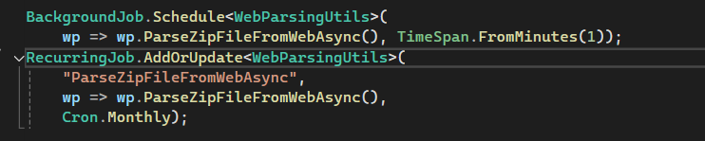

Admin map
MapOSMAdmin component is a component for managing data on a map. The component integrates the Google Maps API for map rendering, autocomplete functionality, and geocoding.

Features
- Google Map Integration:
  - Displays a Google Map with markers for existing and newly added coordinates.
  - Supports map interactions like clicking to add markers and centering on user location.
- Address Autocomplete:
  - Utilizes Google Places Autocomplete to search for and select addresses.
  - Updates the map center and marker position based on selected addresses.
- Marker Management:
  - Allows users to add markers with geographical coordinates and related metadata.
  - Displays existing markers.
- Streetcode QR Code Table Management:
  - Displays a table of all saved street code data, including Streetcode QR ID, latitude, longitude, and address.
  - Allows deleting records directly from the table.
  - Enables assigning unique Streetcode QR code numbers to locations.
  - Validates Streetcode QR code uniqueness before saving.
  - Tracks used and deleted QR codes to avoid duplicates.
- Validation and Error Handling:
  - Checks for duplicate Streetcode QR codes.
  - Ensures valid input for Streetcode QR code numbers.
  - Provides user feedback through styled notifications and error messages.

Google map with Streetcode QR code adding:
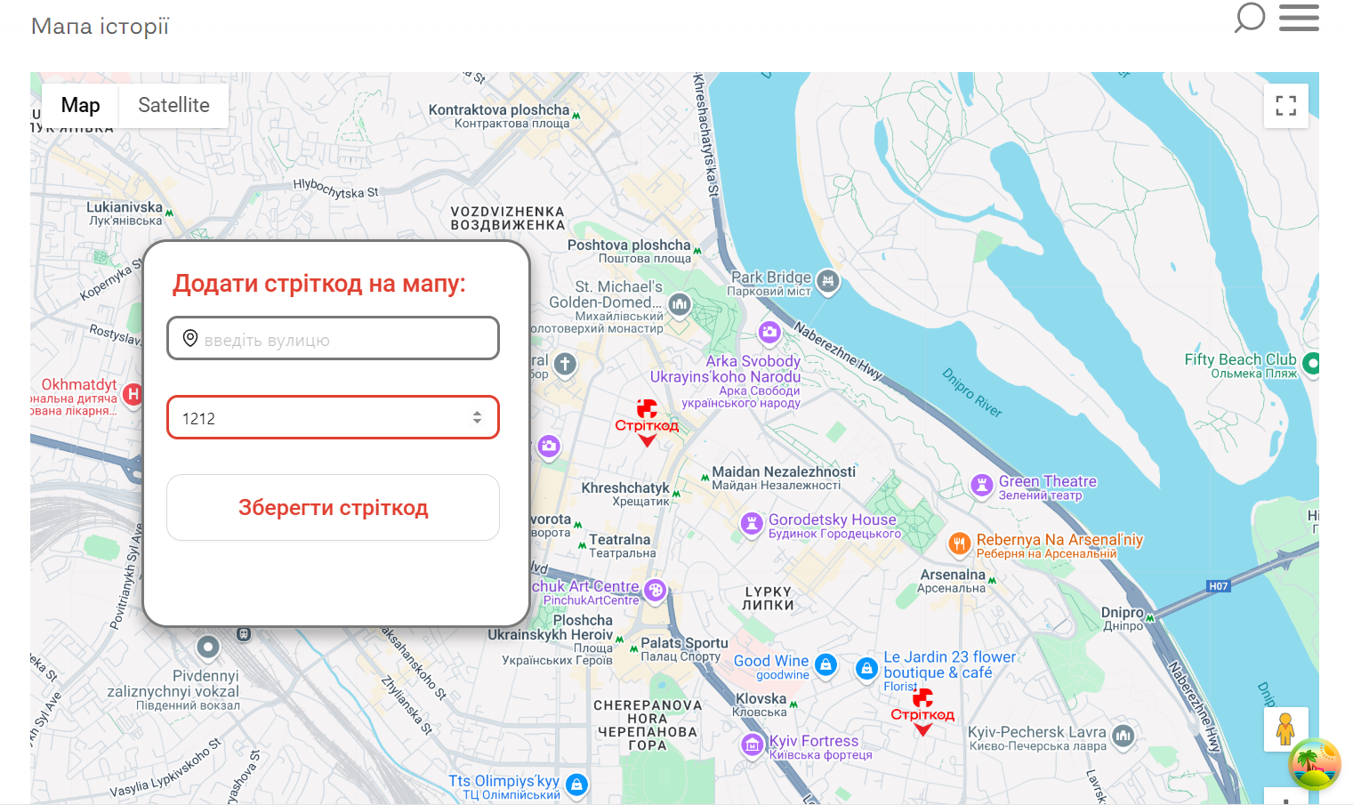

Streetcode QR code table:
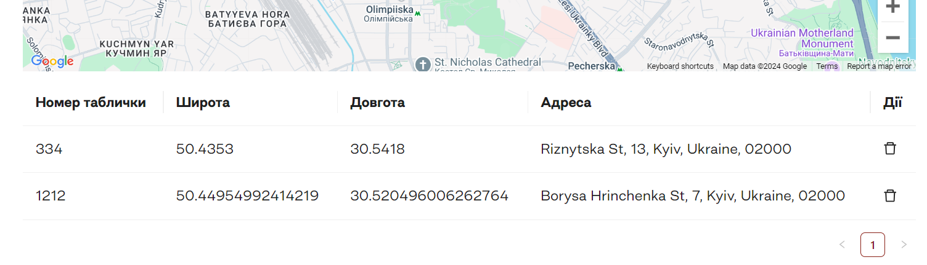
To implement this component, ensure you have a valid Google Maps API key with access to the Maps and Places libraries.

Streetcode map
The MapOSM component is a dynamic and interactive map. It displays markers for statistical records and toponyms on a map of Ukraine. The map uses a custom vector tile layer for styling and clusters markers. Users can toggle the visibility of different data categories (e.g., street codes and streets)

Features
- Dynamic Marker Display:
  - Displays markers for Streetcode QR tables and toponyms data.
  - Supports separate visibility toggles for street codes and street data via checkboxes.
- Marker Clustering:
  - Groups markers into clusters for better map readability when many markers are close together.
- Responsive Design:
  - Adjusts the default zoom level based on the screen width to ensure a user-friendly experience on different devices.
- Custom Styling:
  - Uses a vector tile layer with a custom MapTiler style for map rendering.
  - Integrates gesture handling for improved interaction on touch devices.
- Zoom Control:
  - Provides zoom controls positioned in the bottom-left corner of the map.

Streetcode map:
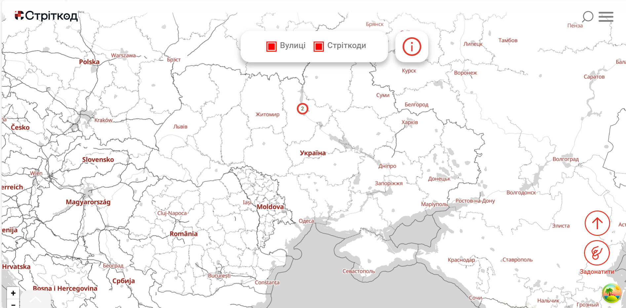

How to make a custom map style with Maptiler:
- Create a Maptiler account ( https://www.maptiler.com/ ) and sign in
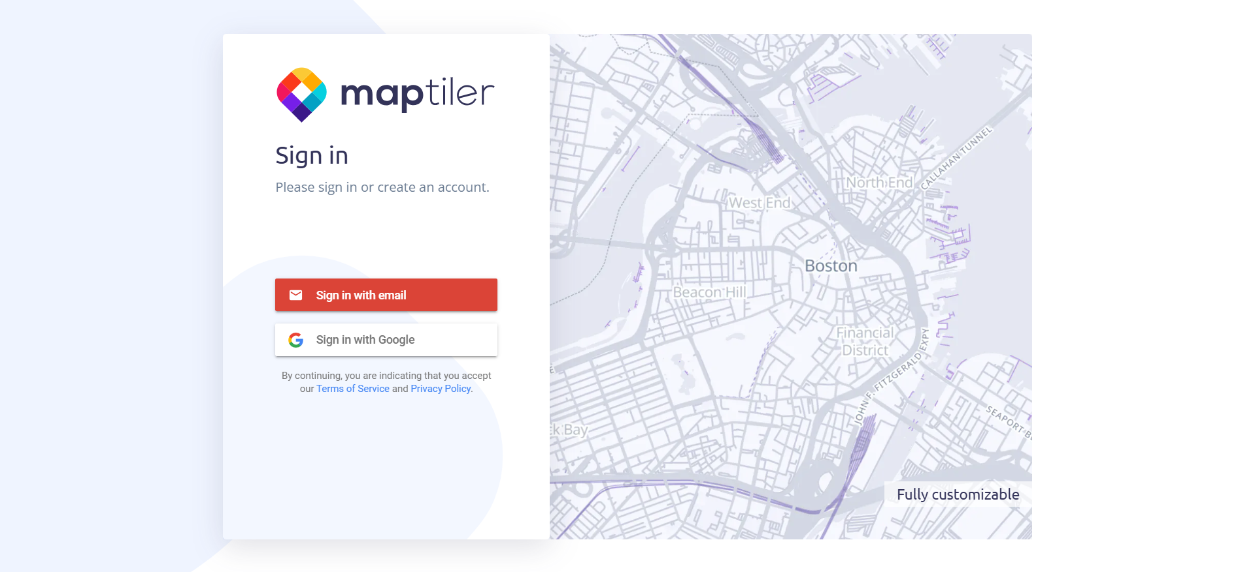

- Go to your cloud ( https://cloud.maptiler.com/maps/ )
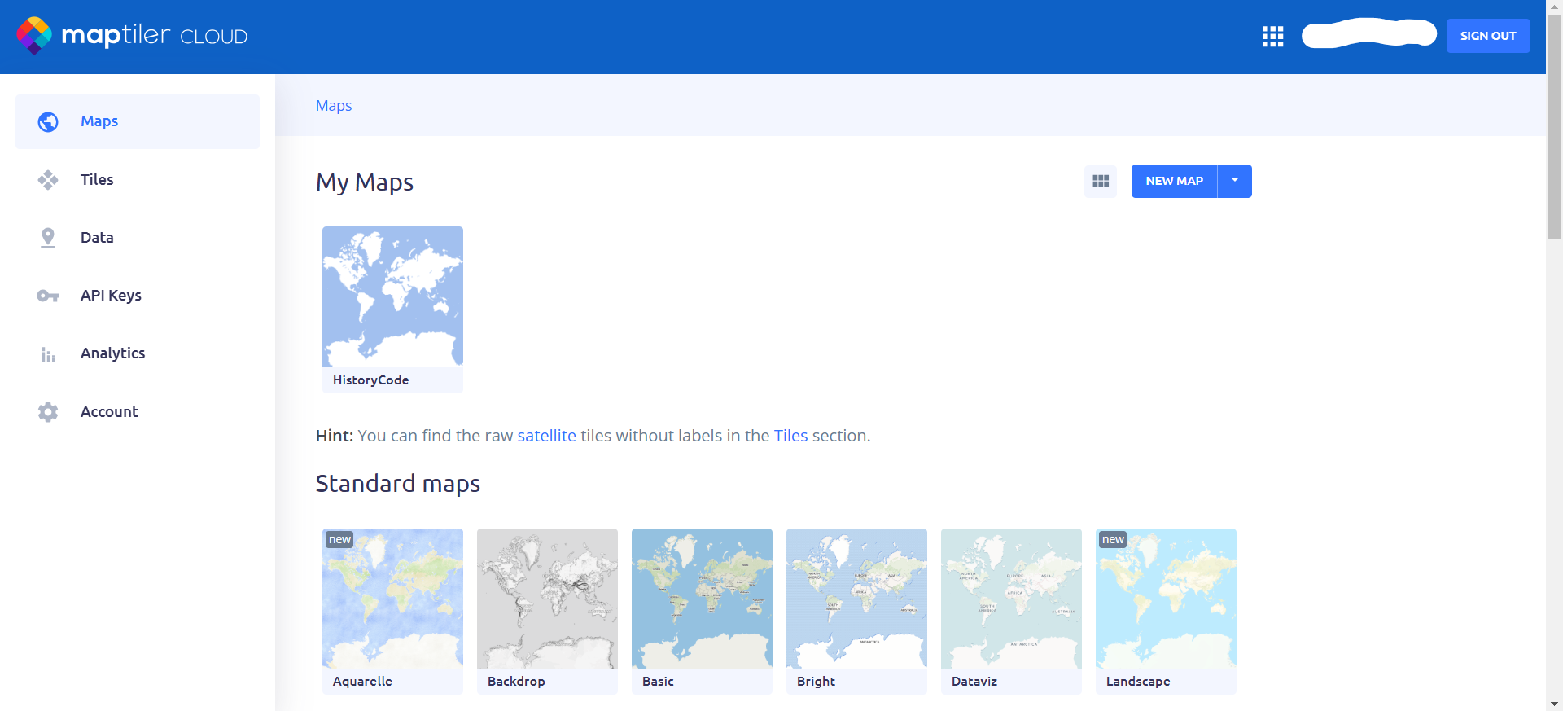

- Choose one of suggested map sources or find your own
Map source used for Streetcode page:
https://www.maptiler.com/maps/#style=basic&lang=name&mode=2d&position=5.2/48.538/31.179
- Click «Customize a copy» or «Make your own map»
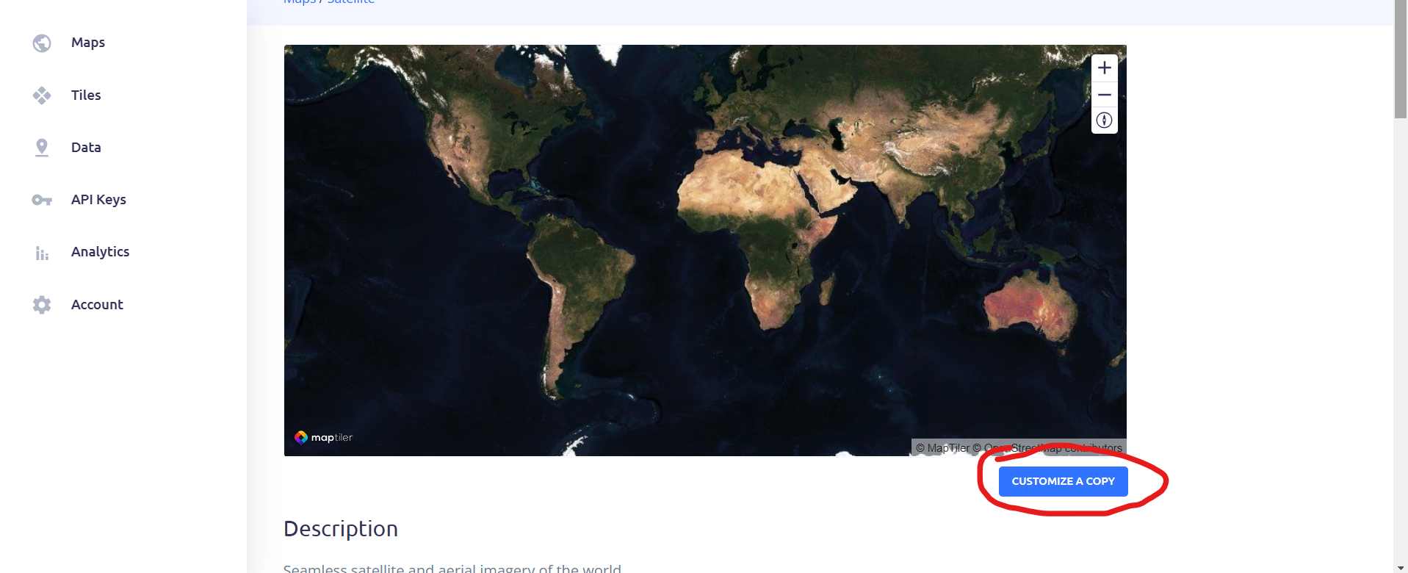
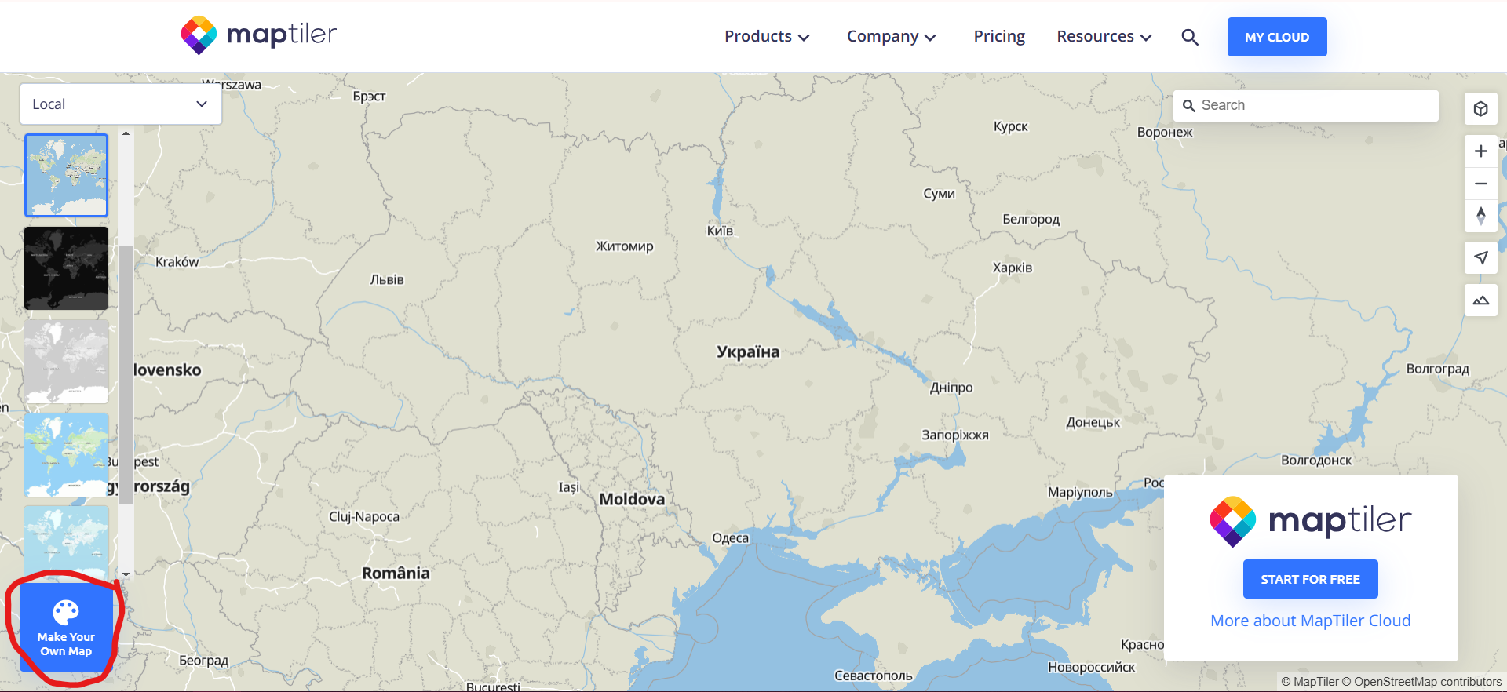

- Change the map style to your preference in the editor
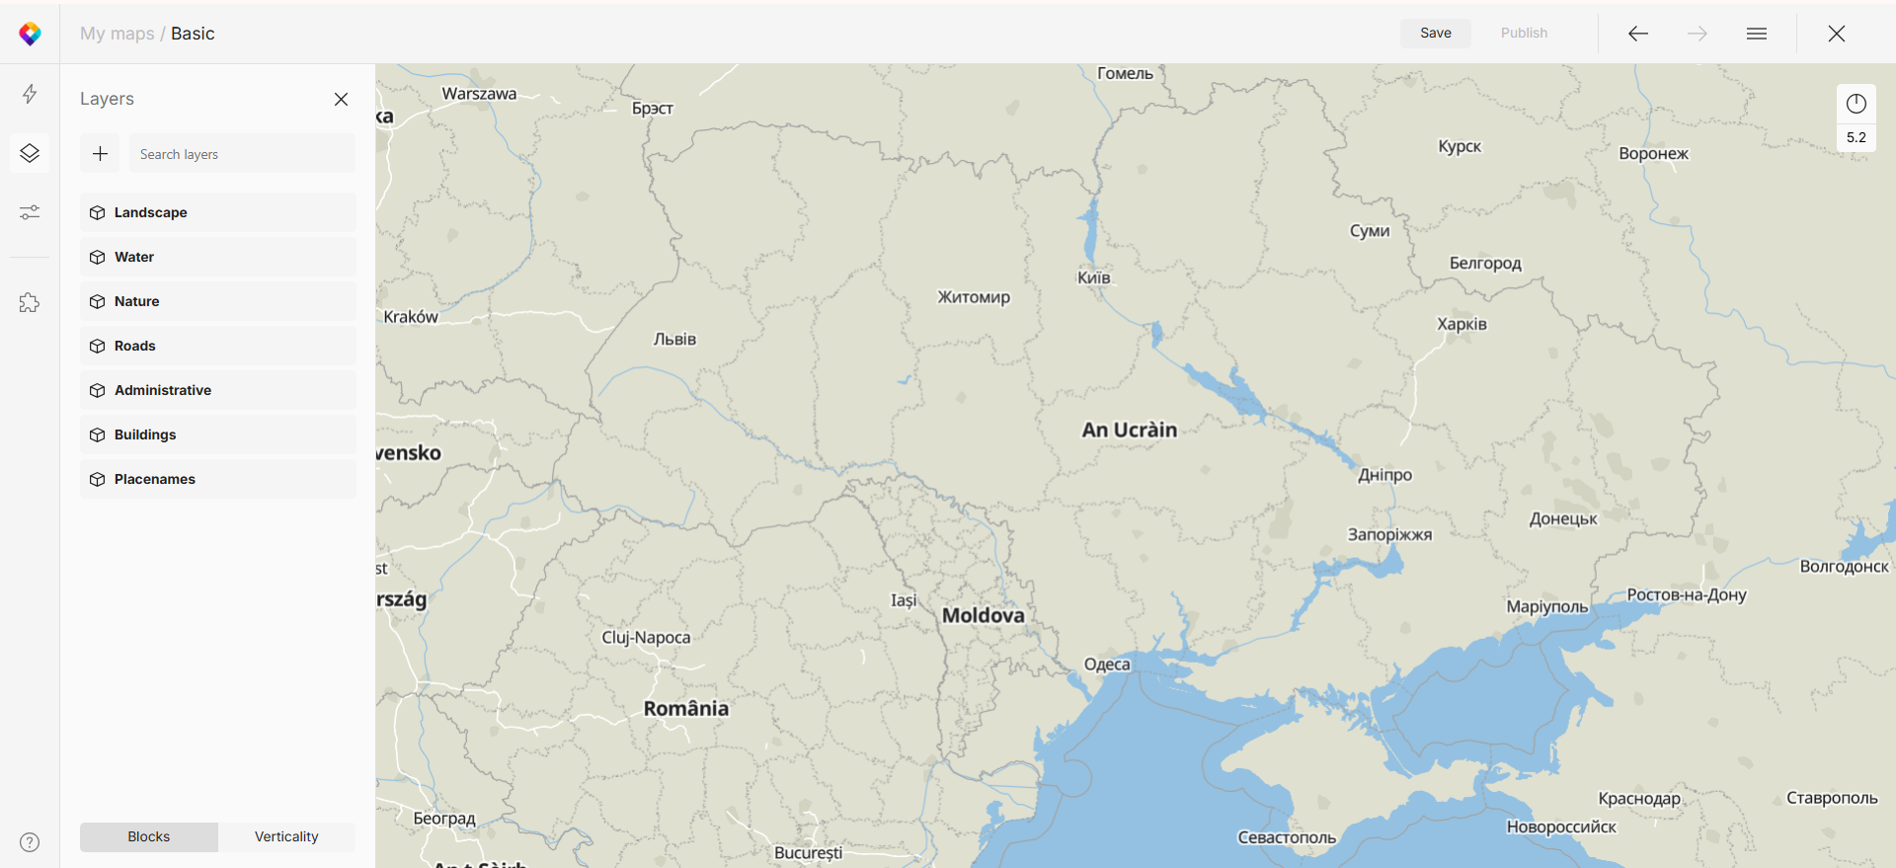

- Save your map
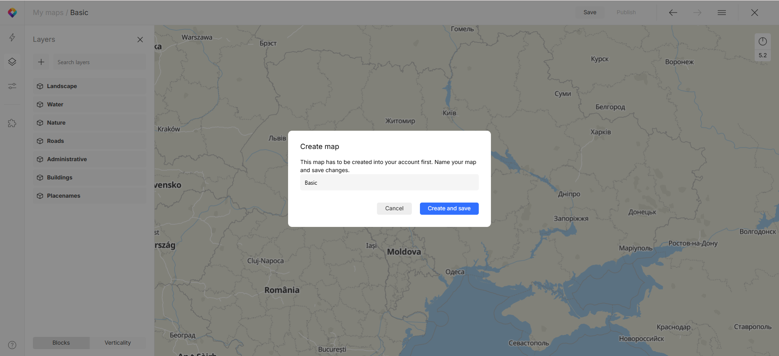
- Now you can find the map in your maps list and use the link to use your custom style in your code
